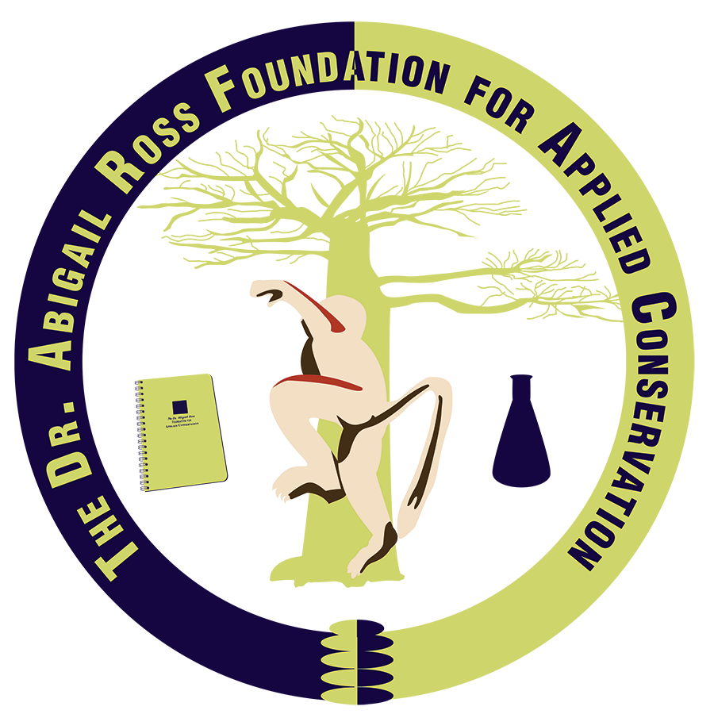
Applied Conservation Grant
Project Proposal Template

- Project Title

- Abstract
- This is a summary of the project. Limit 200 words.

- Introduction
- This is the reason for your study. Include specific goals. Limit 250 words.

- Methods
- This is how you will do your study. Limit 300 words.

- Significance for Applied Conservation
- Frame within the context of plant/animal species, habitats, communities, etc. Limit 250 words.

- Project Timeline
- Include measurable outcomes of success. Limit 200 words.

- Ethical Considerations
- Limit 50 words.

- Predicted Limitations/Setbacks
- These are inevitable components of project implementation and will not be viewed negatively. Gauging potential limitations is important for project outcomes and future work. Limit 100 words.

- References Cited
- Bibliographic style is open to your preference: 1) author-date; 2) footnotes. References are not included in word count requirements. Limit 2 pages.

- Project Budget and Justification
- Include: Expense, unit price, number of units, total in local currency, total in USD, amounts requested from other organizations, and notes.
- Grant funds may be used for international/domestic travel, lodging, meals, and other research-related expenses directly associated with the project. Limit 1 page in table form.

- Short Curriculum Vitae of Principle Investigator
- Limit 3 pages.

