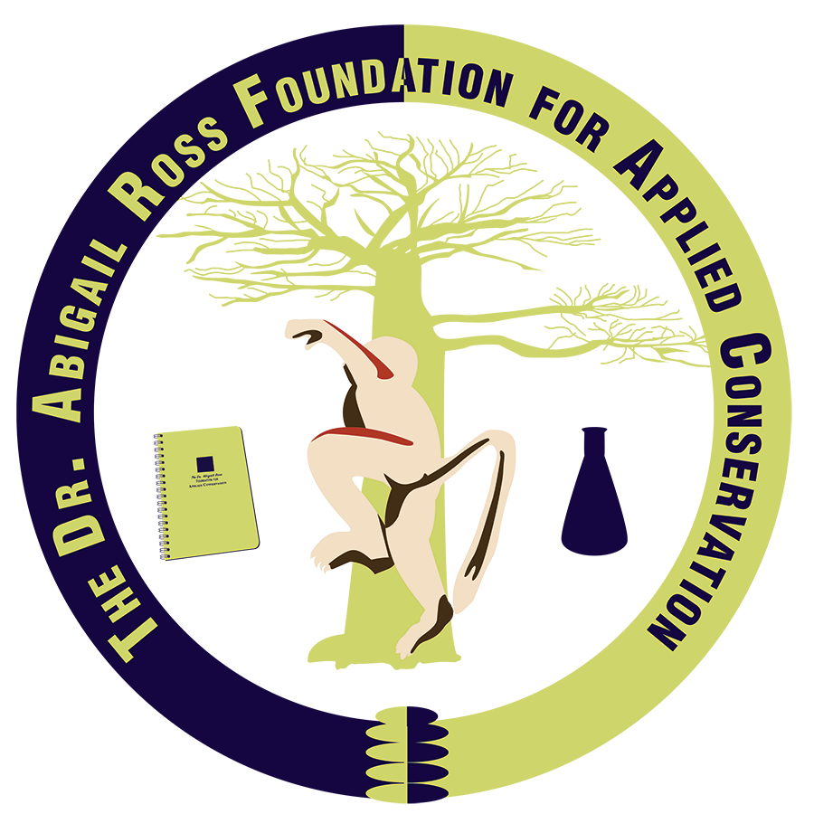
Award Nomination Template
- Nominators: prepare a statement of support (maximum 1,000 words) describing the nominee’s specific qualifications, conservation work, and why you chose to nominate them for either the Devoted to Discovery: Women Scientist Conservation Award or Advocates for Change: Future Conservationist & Activist Award.
- Please focus on past, present, and potential future contributions to conservation science.

